**OpenSwan Lecture.**

1. **Install open swan on both the instances.**



**b)Configure the ipsec config file as below on bothe the instances**



**c)Uncomment this line on the ipsec.config files for both the instances**



**d)Create a file called Oregon-to-california if you are on Oregon Openswan instance. The same file you need to create on the California openswan instance.**



You can get the above file from the amazon documentation, copy the contents and paste

***https://aws.amazon.com/articles/5472675506466066***

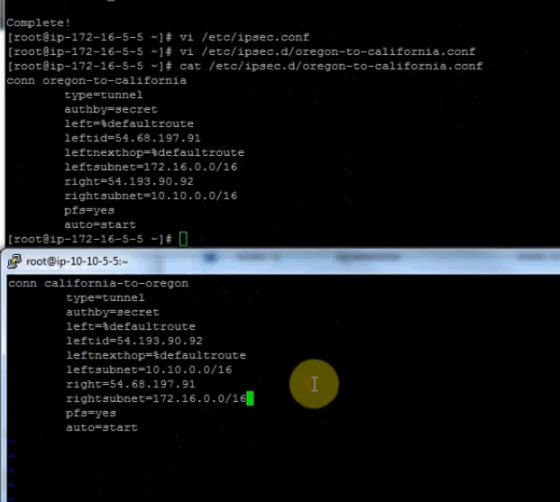

Follow rest as doc but put the below settings.



Uncomment Forwarding =1 and these two line on both the instances

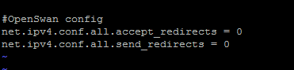

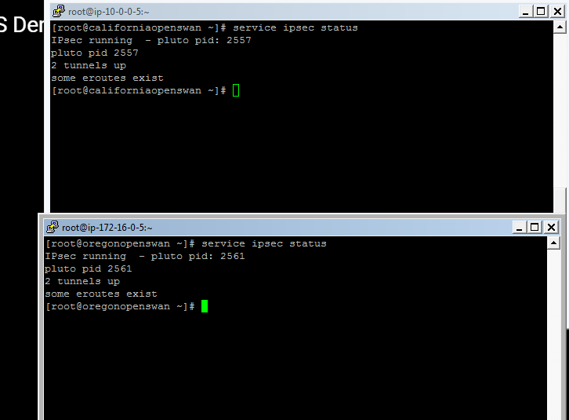

Install the below on both as it lets us know if the packets are coming in and out or not.



Run the below command to see the vpc traffic.



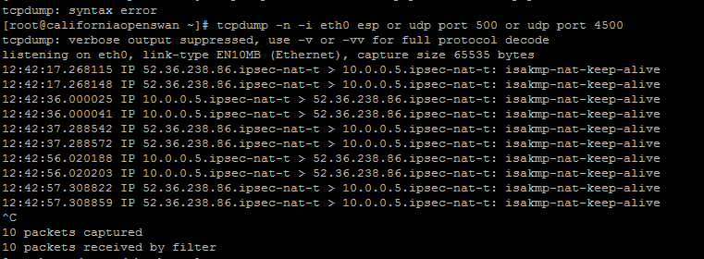

Now its time that both the instances should talk to each other. Run the tcp command on one and ping command on another and see the result.

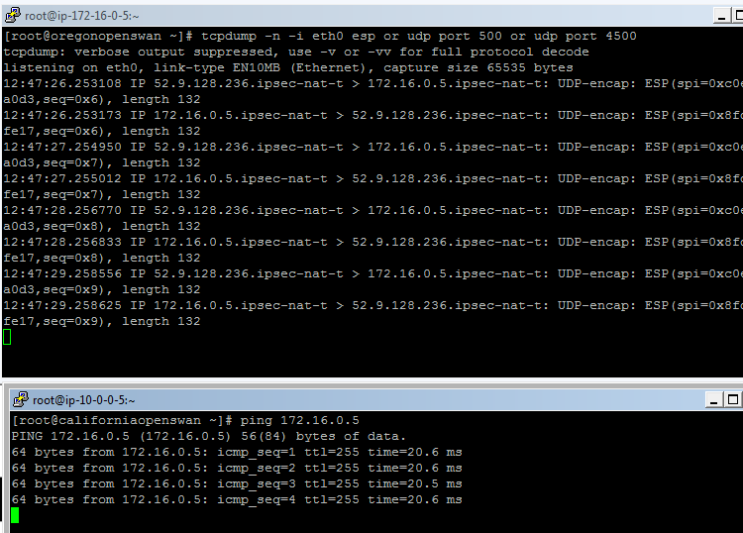

Do the vice versa of above .

For clearification see the below tutorial-- https://www.youtube.com/watch?v=y5V8MKIJETQ